**One-to-One Association**

Using our *Car* and *Engine* example, we develop a one-to-one bidirectional association in this section. To recap, we know that every car will have one engine (we are not talking about those exotic twin-engine sports cars!) and every engine is fitted to a car; hence, they exhibit one-to-one mapping.

There are two ways of establishing a one-to-one association: using a **primary key** and using a **foreign key.** The difference is not apparent in the object model but is evident in our relational model. We’ll go through both ways here. The persistent entities will be the same in both cases, so let’s start defining them first.

The following snippets define the relevant *Car* and *Engine* classes:

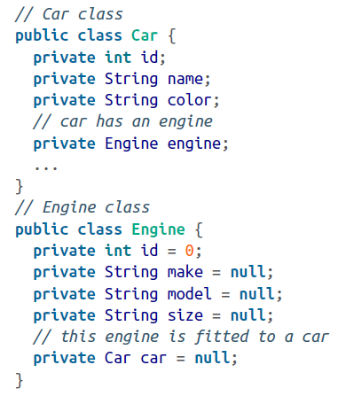

Did you notice the references of *Car* in the *Engine* class and *Engine* in the *Car* class as *engine* and *car* references? This is the way we express our associations in the Java languages.